SYNAPSE ITS INTRODUCES SYO™, A NEW ECOSYSTEM FOR INTELLIGENT SIGNAL MONITOR OPERATIONS
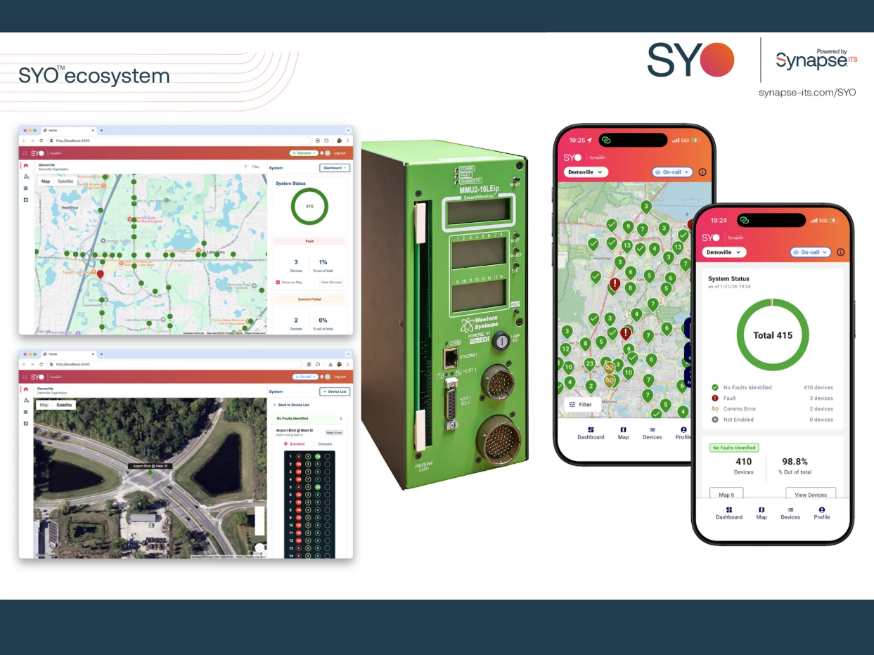
Traffic agencies rely on accurate information to maintain safe and reliable intersections. Today, understanding what is happening at a signal cabinet often requires field visits, manual diagnostics, and time spent tracking down issues.
Synapse ITS is changing that approach.
On February 18, 2026, Synapse ITS announced the launch of SYO™, a new connected ecosystem designed to bring greater intelligence, visibility, and efficiency to signal monitoring operations.
A Smarter Approach to Signal Monitor Management
SYO represents a major evolution of the Synapse ITS platform. Instead of managing individual devices in isolation, the ecosystem brings device data, diagnostics, and operational insight into one secure environment.
Built specifically for signal technicians and supervisors, SYO transforms monitor alerts into actionable insights. Teams can quickly understand what is happening at an intersection before dispatching a technician, helping agencies respond faster and operate more efficiently.
A Connected Ecosystem for Modern Traffic Operations
SYO connects compatible Eberle Design (EDI) signal monitors into a scalable system that can support dozens—or even thousands—of intersections.
Through a unified interface, technicians can access system information from:
- Smartphones
- Tablets
- Desktop computers
This flexibility allows agencies to monitor and manage infrastructure from both the office and the field.
According to Synapse ITS CEO Geoff Wilcox:
“With SYO, we are taking the next step in Synapse’s evolution by moving beyond individual products and delivering a true connected ecosystem. This is about giving customers clearer insight into their operations, faster response to issues, and greater confidence in managing critical infrastructure.”
Key Benefits for EDI Signal Monitor Users
SYO helps traffic agencies streamline operations and improve response times through several core capabilities.
Faster visibility into issues
Text and email alerts notify teams when and where problems occur, helping technicians respond quickly.
Reduced field visits
Detailed device logs and system status can be accessed remotely, allowing teams to diagnose problems before dispatching field crews.
Improved uptime and efficiency
Better insight into device behavior helps reduce unnecessary truck rolls, shorten service calls, and restore normal intersection operations more quickly.
Synapse ITS CTO Josh Little Sun emphasized the role of data in the platform’s development:
“We are focused on embedding deeper intelligence into every layer of our technology. SYO points to a future where data leads to more practical insights, putting our expertise directly in the hands of technicians and supervisors.”
Supporting the Future of Connected Infrastructure
As transportation infrastructure becomes increasingly connected, agencies need tools that provide clear visibility into system performance and operational health.
SYO helps bridge that gap by turning device data into practical operational insight, helping agencies maintain traffic systems more efficiently while improving reliability in the field.
SYO (pronounced “sigh-oh”) is now available.
Compatible Devices.
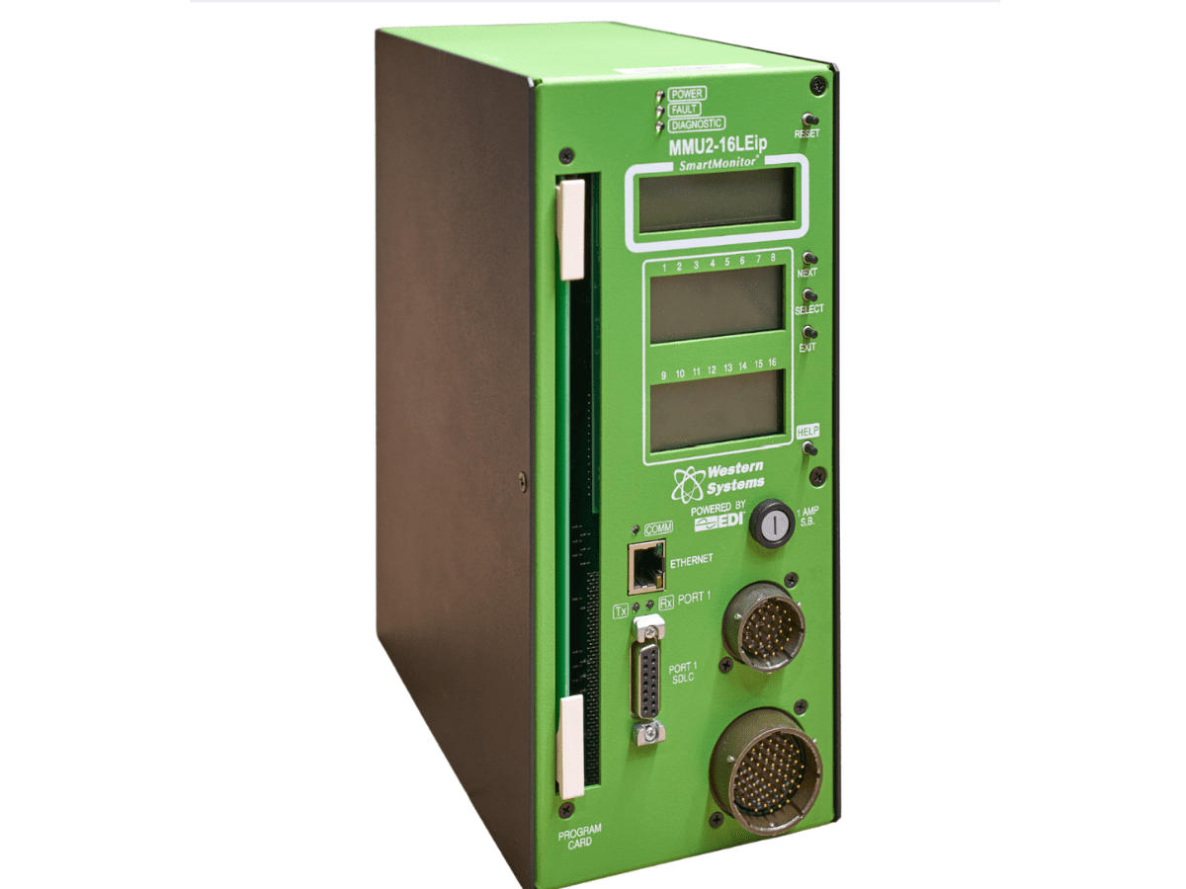
The SYO ecosystem works with Powered by EDI Western Systems signal monitorMMU2- 16LEip WS and MMU2-16 LEip. Including ; 2010ECLip; 2018KCLip; CMUip2212-HV
To learn more and view compatible EDI signal monitors, visit:
SYO Ecosystem
SYO Website
About Synapse
ITS Synapse ITS brings together several industry-leading transportation technology brands, including Polara, Carmanah, Eberle Design (EDI), Diablo Controls, Availed, and GovComm.
The company focuses on improving roadway safety, accessibility, and operational efficiency through intelligent infrastructure solutions. From intersections and highways to crosswalks and parking systems, Synapse ITS combines durable hardware, advanced software, and data-driven insights to help agencies address complex transportation challenges.

